Fleet Street Heritage Sundial - Heritage Statement

- The site

The site is the flank wall of no. 61 Fleet Street, which forms the first 10 metres of the right-hand side of Bouverie Street from the Fleet Street corner. At first glance, this may appear to be a rather dull site, but it conceals a wealth of history of the early British newspaper industry and of the struggle to secure the freedom of the press.
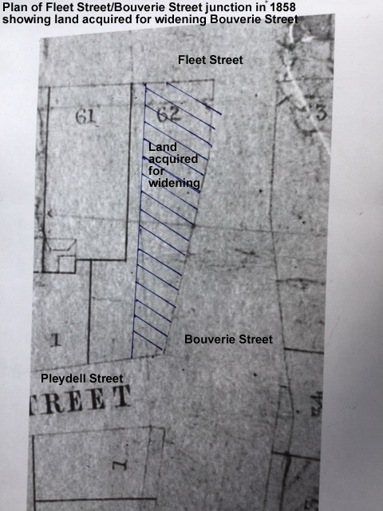
The site was, until the 1850s, an interior wall of no. 62 Fleet Street. The house was demolished, probably around 1880, to enable the top end of Bouverie Street to be widened from about 10 ft to its present width. However, a strip of land 2 ft. wide was not required, so it was left on the title of 62 Fleet Street, and a new building, now known as 62 Fleet Street, was constructed at the rear of no. 61.

The original 62 Fleet Street was, in the early 1800s, the printing and publishing house of Richard Carlile. His newspaper, The Republican, was the only one to publish a report on the Peterloo Massacre in 1819. He was sent to prison three times for publishing material which the government of the day disapproved of, including the works of Tom Paine.

But for this historical accident, the blank wall would probably not exist at all, and the flank wall of no 61 would have been punctuated by windows.
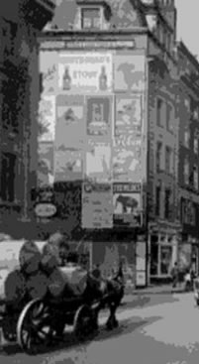
In the twentieth century, successive owners of the wall have used its unique position to generate money from advertisements. There is a picture from the 1930s showing 16 posters in a 4 x 4 grid on this wall.
After the war, the posters became fewer, and more garish, with, latterly, some large illuminated posters. These posters contravened the planning policies of the City, at present incorporated in policy DM10.6 which restrains advertisements above ground level. The end-result is that this wall makes no contribution at all to developing or enhancing the appearance of the conservation area. The current application is an imaginative suggestion for how this situation could be radically changed.

- Impact of the proposal on the character and appearance of the Fleet Street Conservation Area

We have referred to all the relevant sections of the “Fleet Street Conservation Area – Character Summary and Management SPD” of 23 February 2016, and will not itemise them here. It refers frequently to the major impact of the newspaper industry on Fleet Street in former times, and to the fact that “evidence of the former association with printing and publishing is less obvious”, and that the few remaining reminders, such as the mosaics spelling the names of the Dundee Courier and related publications at no. 186 “hint at the extend to which the industry dominated the area”

The impact of our proposal would be to bring all these rich historical associations with the newspaper industry to the foreground of people’s attention. The association with the newspaper industry would no longer be a matter of specialised interest to those who already knew something about it, but would be made easily accessible to all through the three components of the proposal – the sundial with its immediate visual impact on passers-by, the explanatory panel at the base of the wall (which would give more background information about the struggle for the freedom of the press and the newspaper industry in Fleet Street) and the associated website which would give a wealth of further information for anyone with a serious interest.

- The views from Fleet Street and Bouverie Street

The pictures below show how much of the wall is visible from various points on the northern pavement of Fleet Street. The sundial will make a bold impact for a distance of about a hundred yards on Fleet Street. It will not be visible from Ludgate Circus (view no 2 in the Conservation Area document) nor in any other of the views listed there. The view of the sundial from Bouverie Street will be minimal since it will be almost side-on
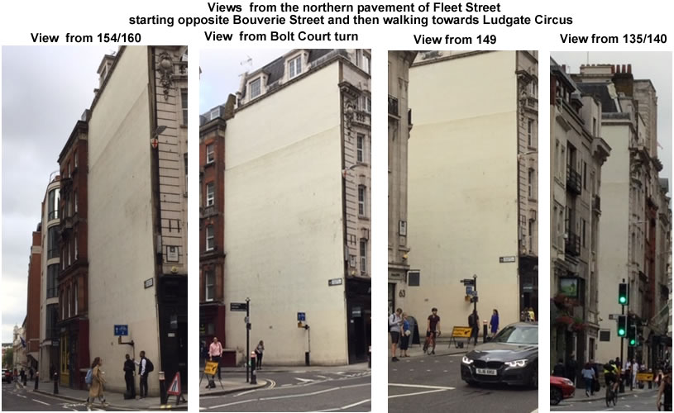

For more detail, see http://fleetstreetheritagesundial.uk/62FleetStreetStory.pdf which shows other pictures of the wall over the last 50 years

