Fleet Street Heritage Sundial - Design and Access Statement

Piers Nicholson is a sundial designer who has produced an innovative horizontal sundial, the Spot-On Sundial, of which some 2,000 have now been made. He has also designed a number of public sundials, including the Tylers and Bricklayers Millennium sundial on Paul’s Walk in the City.

Several years ago he moved in to a Flat in 62 Fleet Street, got curious about the blank wall on the flank of no. 61, and wondered what could be done to make it more interesting.

The result was the idea for this sundial. It has taken over a decade to develop, largely because of the difficulty of persuading successive owners of the wall that they would like to have a sundial on it.

The purpose of the sundial is to remind the many users of Fleet Street (residents, City workers, and tourists) of the worldwide reputation of Fleet Street in the days when it was the hub of the newspaper industry, and also to provide a permanent memorial to those like Richard Carlile (who lived on this site) and others who fought and suffered for the freedom of the press.

The design of sundials is tightly constrained by the mathematics of obtaining a consistent shadow. The gnomon (which casts the shadow) has to be pointing at the North Celestial Pole. To achieve this, the gnomon must be pointing to true North (viewed on plan) and the angle of elevation must be the same as the latitude. If the dialplate is at right angles to the gnomon (that is, in the plane of the equator) the hour lines are at 15 degree intervals. If the dialplate is at any other angle, the hour lines are the projection of these 15 degree intervals on that surface. In the special case of vertical sundials facing exactly east or west, the gnomon has to be held out parallel to the wall and the hour lines are parallel lines at the angle of the latitude as in the east and west dials on the tower of St. Margaret’s, Westminster (pictured).
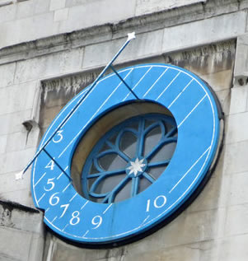
East facing dial on St. Margaret’s Westminster

The wall discussed in this proposal is facing some 7 degrees away from east, so the hour lines are not quite parallel to each other.

Design of the Fleet Street Heritage Sundial project

The project can be divided into four sections:
The face of the sundial located on the wall
The gnomon projecting out from the top left corner of the sundial face
The three explanatory panels at head height at the foot of the wall
The fleetstreetheritagesundial.uk website

The sundial face is marked out with the lines where the shadow falls for every hour between 6 and 10 with additional lines at 10.30, 10.45 and 11. Between the six lowest of these lines appear the mastheads of 5 newspapers. The particular newspaper titles to be used have not yet been selected, but 3 or 4 of them will be newspapers no longer published (starting with the Republican which was printed on this site) and 1 or 2 of them will be current newspapers.
The final selection of newspaper mastheads to be included in the sundial will be decided in consultation with local interests such as the Castle Baynard Ward Club. The hour lines and the newspaper mastheads will be painted on the wall by a very experienced signwriter who has undertaken major projects in London. The wall surface will be carefully examined and made good where necessary. The wall will then be treated with a stabiliser, and then painted with 2 coats of acrylic masonry paint such as Finngard Opaque alkyd-reinforced acrylic paint sheen finish. This has a tested life of over 10 years; since this wall is only exposed to direct sunlight for a part of the day (and not the hottest part) the anticipated life is between 15 and 20 years. The painting is expected to take about 3 weeks, and will be done from scaffolding.

The position and size of the gnomon is determined by the mathematics derived from the orientation of the wall relative to due South. The gnomon will be fabricated from stainless steel tube with welded joints between the components and with stainless steel fixing plates to attach it to the wall. the attachment will be done by suitable anchor bolts into the wall.

The 3 plaques will be made out of 5 mm. marine grade stainless steel, which will be deep-etched. This will ensure that the text is readable for many years to come.

Draft text for the three plaques at the base of the wall

Freedom of the Press
Number 62 Fleet Street stood on this site until it was pulled down to widen Bouverie Street in the late 1800s. It was the printing office of Richard Carlile who published “The Republican” here from 1819 to 1826. He was present at the Peterloo massacre in 1819, and published the first report of it in London. Carlile also published “The Rights of Man” and other books by Thomas Paine. The Government attempted to shut down “The Republican” on many occasions and Carlile was prosecuted and sent to prison three times.

Fleet Street Heritage Sundial
Fleet Street was the hub of the British newspaper industry for over 100 years until the late 1980s when the need to adopt new technology, to work in modern buildings, and to modernise their labour relations caused them to move to other parts of London. The sundial on the wall above commemorates some of the newspapers which made the name of Fleet Street famous throughout the world, and the individuals like Richard Carlile who spoke out for the freedom of the press which we enjoy today

More about sundials
Sundials are a very ancient technology, starting in Egypt and Greece over 2000 years ago. Our website, www.fleetstreetheritagesundials.uk, tells you more about this east-facing sundial, which only tells the time in the morning.
It has a link to the Thames sundial trail at www.sundials.co.uk/trailthames, which will take you to other fine sundials nearby. This website also has a wealth of other information about sundials, including projects for you to do, technical explanations, pictures of sundials worldwide, and other sundial trails

Drawings
Site plan (indicated by red line at north end of Bouverie Street
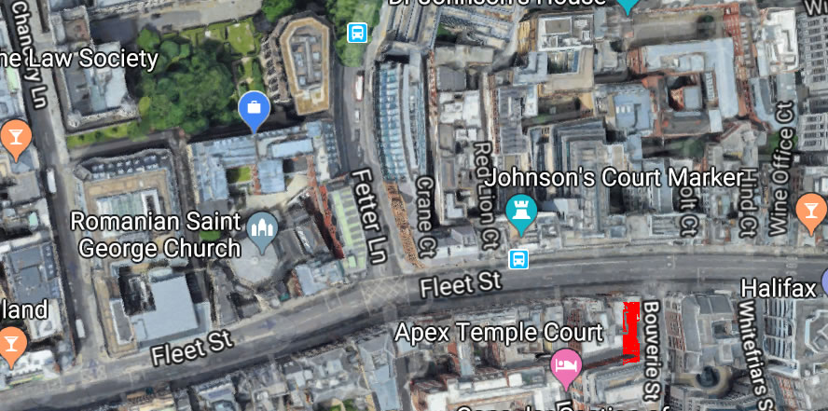

Elevation of wall showing hour lines and illustrative newspaper titles and view of the wall from the junction of Bolt Court and Fleet Street

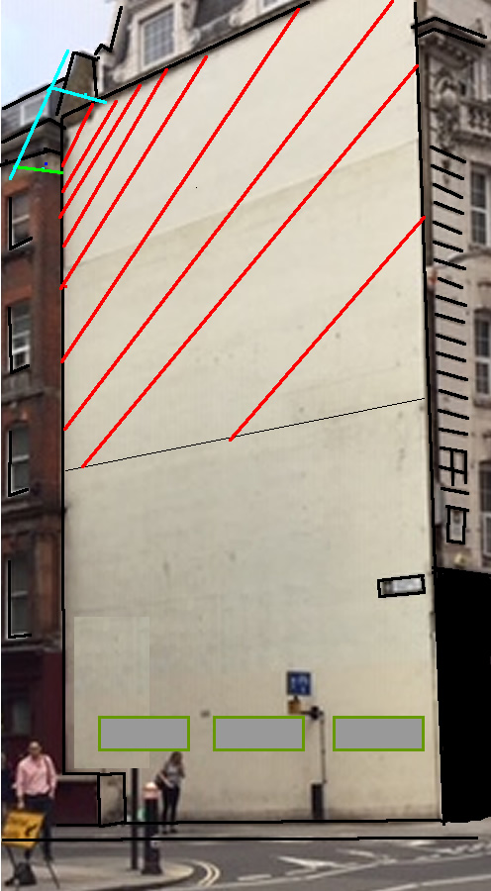
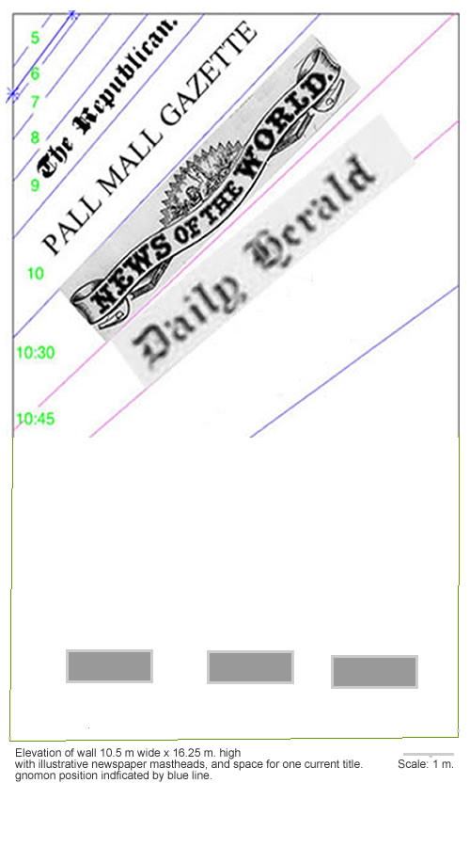

This drawing shows the detail of the gnomon at the top left hand corner of the sundial

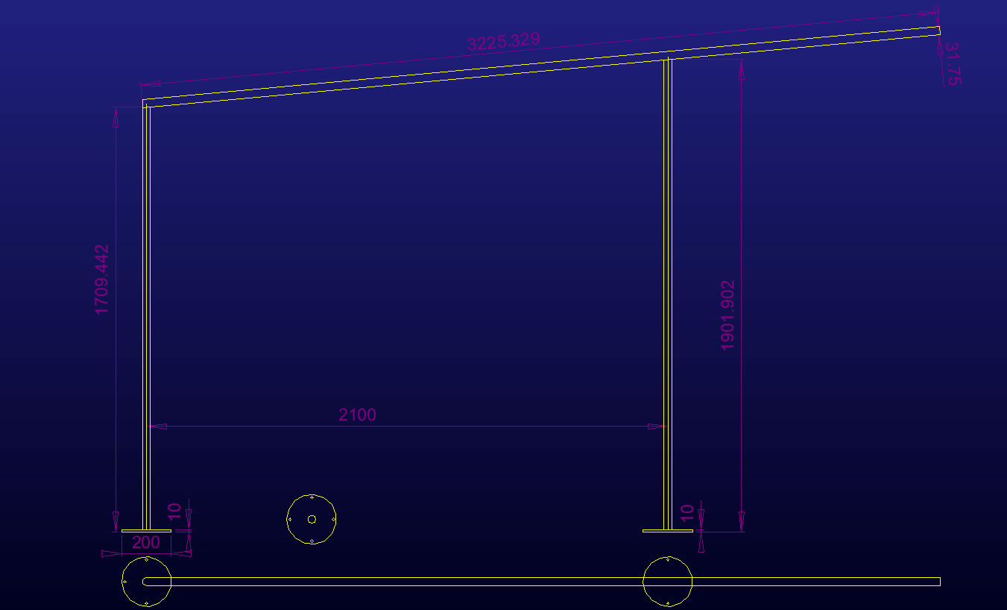

More details at http://fleetstreetheritagesundial.uk/designer.html
As the Savoy dial in the Embankment Gardens or the Timepiece dial at Tower Bridge, both illustrated at https://www.sundials.co.uk/trailthames
As the Queens Walk sundial designed by Piers Nicholson – see http://www.queenswalksundial.co.uk/

